Department Of Computer Science

Gujarat University

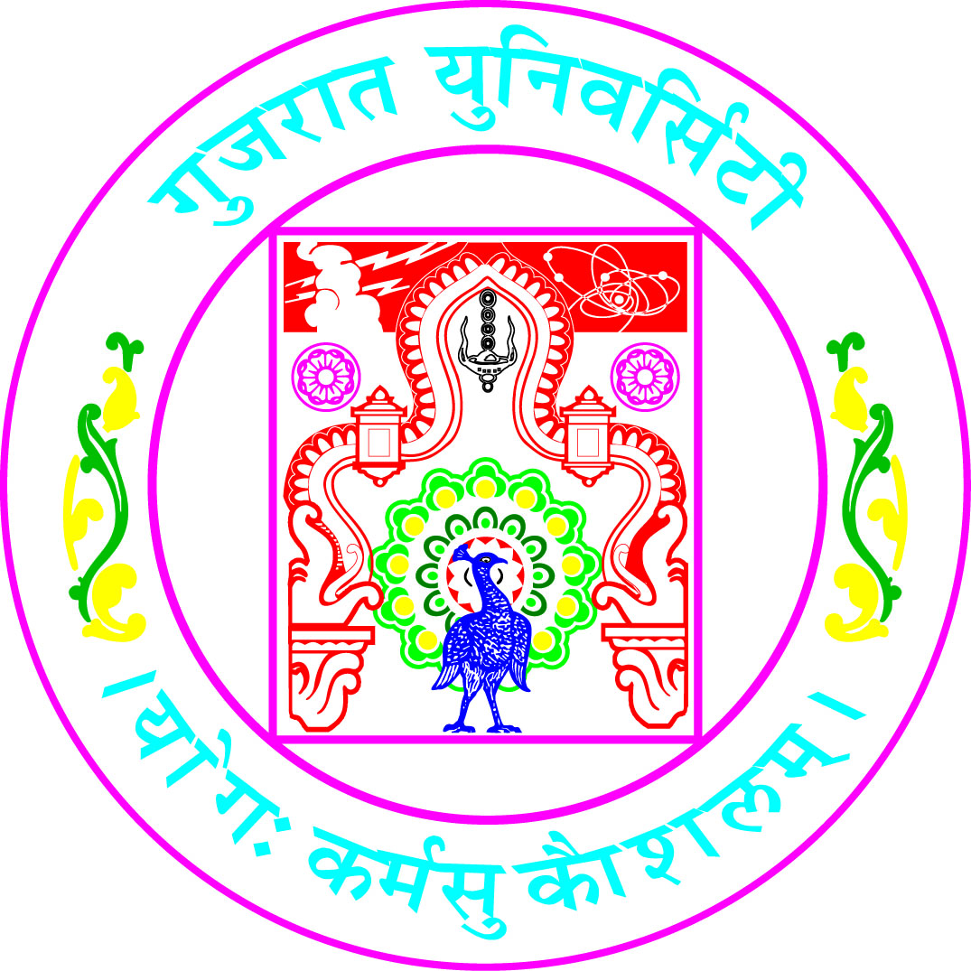

CERTIFICATE

This is to certify that research work embodied in this report entitled “National Stock Exchange Stock Price Prediction using Deep Learning” was carried out by Mr. Mohamed Umar Ranginwala (40003-DS) at Department of Computer Science for partial fulfillment of M.Sc (Artificial Intelligence & Machine Learning) – Defense Specific degree of Gujarat University. This research work has been carried out under our supervision and is to our satisfaction.

Course Coordinator Supervisor
Dr. Jyoti Pareek Ms. Vaishnavi Sharma

Head of the Department
Dr. Jyoti Pareek

